MACH4METAL

metalworking machinery
Transito 21, 6909 DA Babberich, Netherlands
Tel. + 31 (0)316 – 247123
Fax. + 31 (0)316 - 247956
info@mach4metal.com
www.mach4metal.com
Bank No : 66.52.13.883
IBAN : NL33 INGB 0665 2138 83
BIC : INGBNL2A
VAT : NL 815393635B01

CNC Lathe MEXPOL TUB 840 x 4000 mm

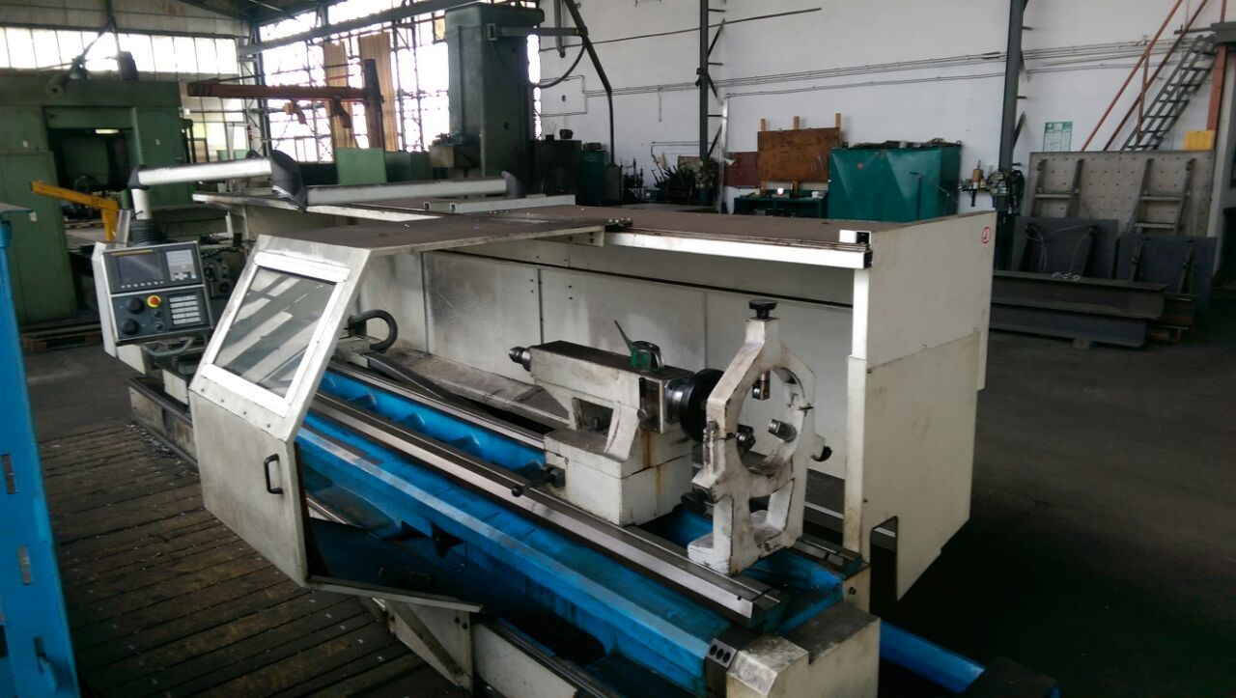
- Make : MEXPOL Werkzeugmaschinen
- Type : TUB 830 C x 4000
- Age : 2008
- No : 2476

- Centre height : 400
- Swing over bed : 830
- Swing over carriage : 585
- Centre distance : 4.000
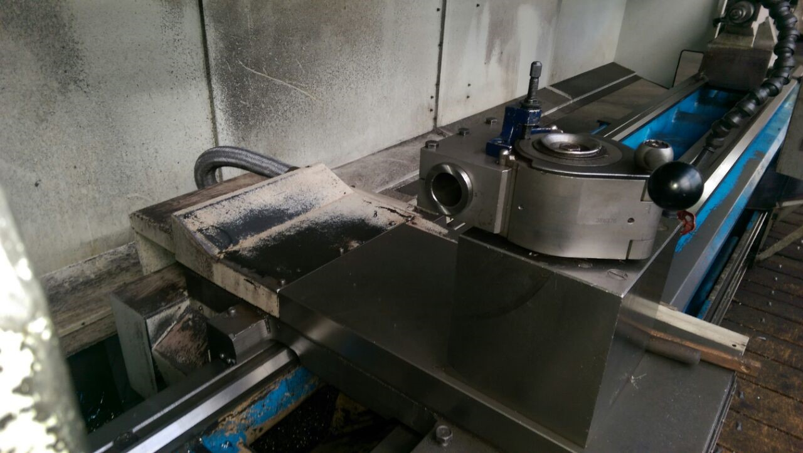

- Bed width : 520
- Spindle bore : 103
- Power : 15 KW
- Speeds 3 steps : 18 – 1.015

- Work piece load :2.400 Kg
- Flying in chuck : 400 Kg
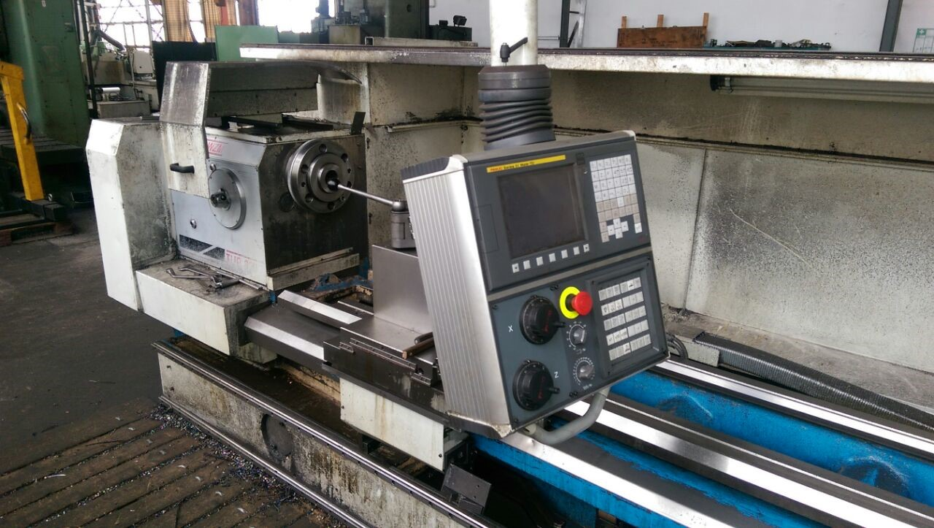

- Fanuc O-i Mate TC
- Chip back side cover with door
- Excellent condition !

- Dimensions
- Length : 6.310
- Width : 2.200
- Height : 2.100
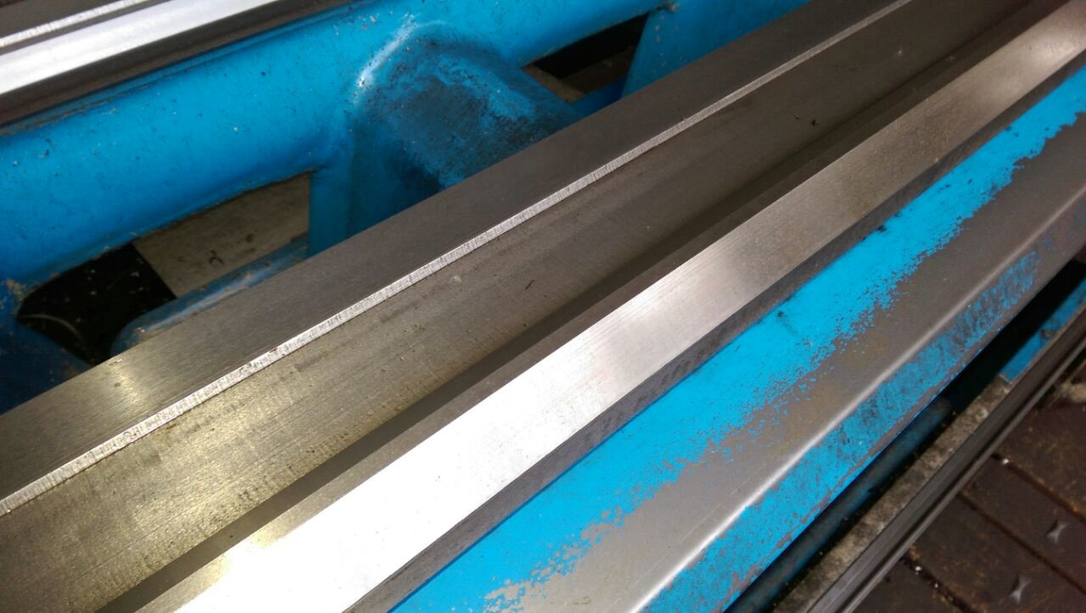
- Weight : 7.000

- incl 4 chuck 800 / 400 / 3 chuck 400
- incl. 2 x steady rest
- incl. tool system
- incl. documentation

Please Note: The above information has been obtained to the best of our ability and belief from, and from the manufacturers where possible. It is given in good faith, but its accuracy can not be guaranteed. Accordingly, it will not form a representation or constitute contractual terms. We advise you to check any vital details!

